|  |  |  |
| --- | --- | --- |
| **Lyng Primary School P.E Knowledge Organiser** | | |
| **Topic: Tennis** | Year 3 | Summer 1 |

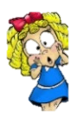



|  |  |
| --- | --- |
| **Key words** | |
| **Spelling** | **Definition** |
| Serve | A type of shot, that starts or restarts the game following a point, ball thrown above your head and hit using an overarm technique. |
| Rally | When a ball is hit back n forth between yourself and an opponent. |
| Forehand | Type of tennis stroke, racket in strongest hand sideways on. |
| Volley | A volley shot hitting the ball without bouncing. |
| Stroke | Different types of strokes, where you are hitting the ball back at an opponent. |
| Singles | 1 player vs 1 player |
| Doubles | 2 players vs 2 players |

**Enquiry Questions**

* How can we develop our accuracy?
* Can we react sharply to ball movements to help return a shot?
* Can you score point when using a forehand shot?
* What is a volley shot?
* How do you perform a backhand shot?
* Can we show accuracy when completing a rally?

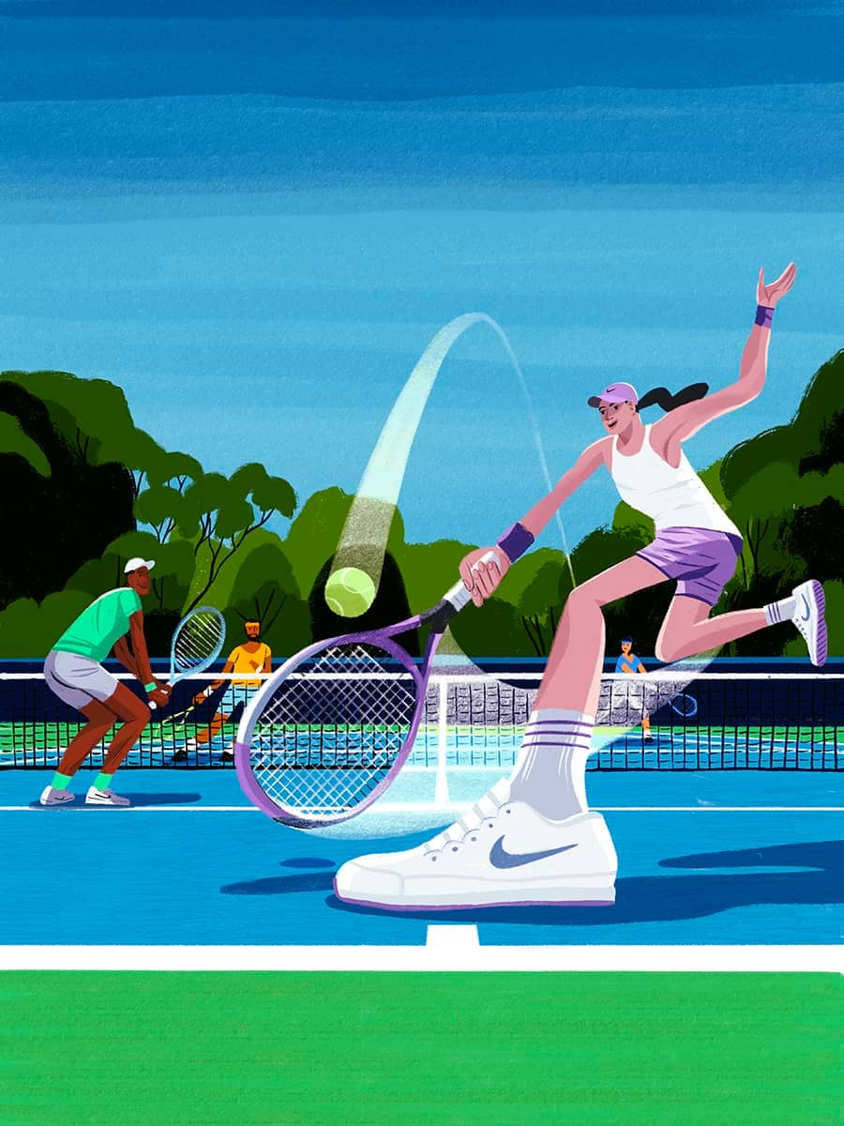

***“Don’t let anybody work harder than you” Serena Williams***

**– Mav Levy**

|  |  |  |
| --- | --- | --- |
| **Lyng Primary School P.E Knowledge Organiser** | | |
| **Topic: Tennis** | Year 3 | Summer 1 |

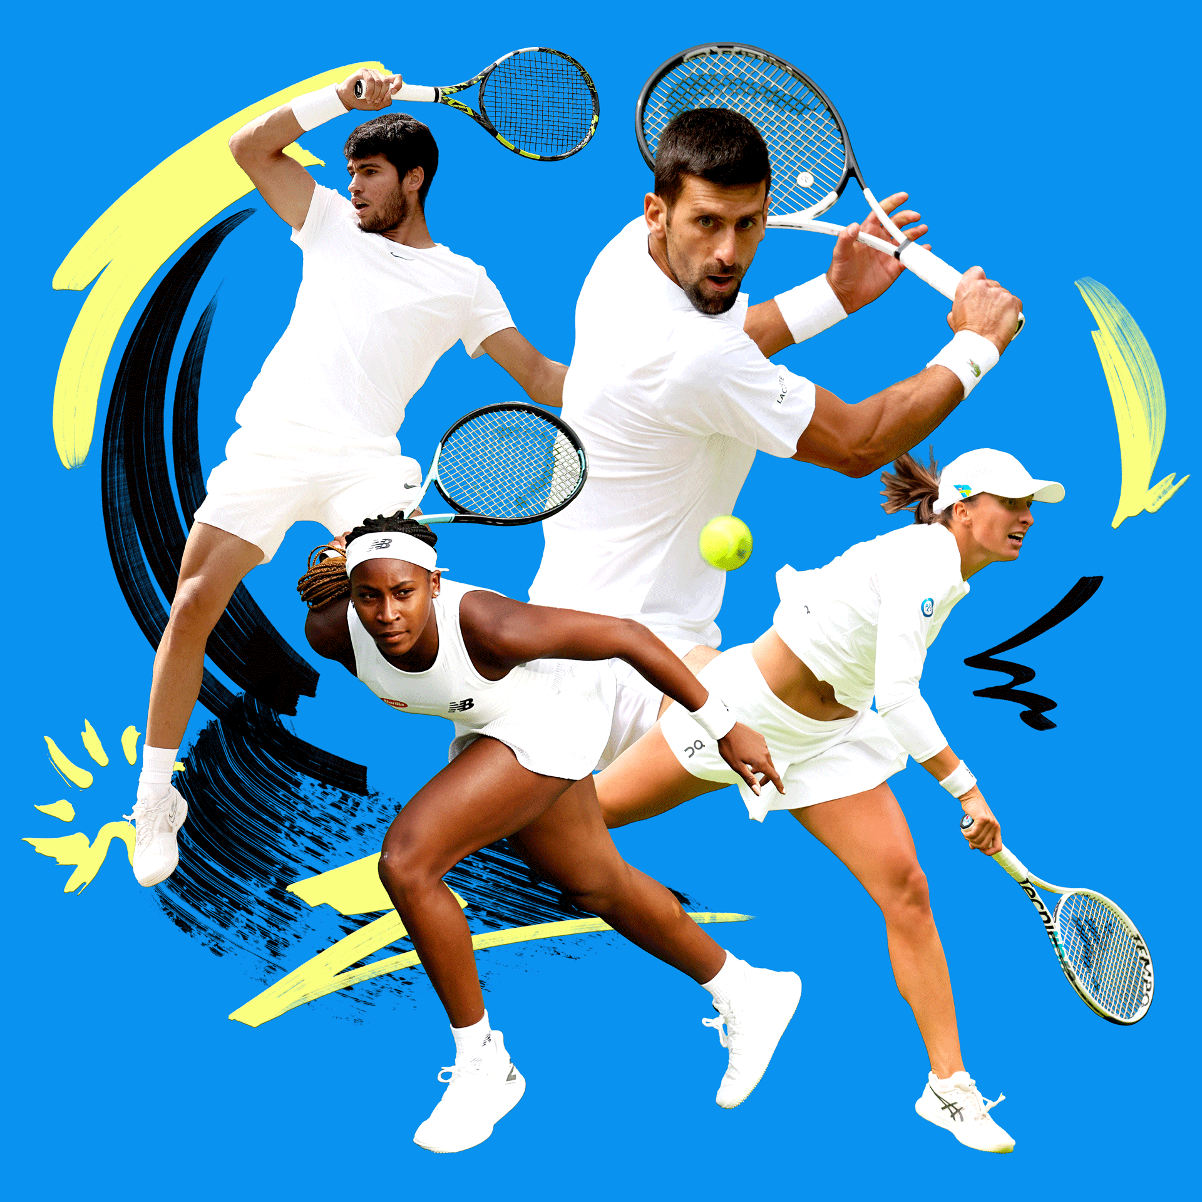

Learning Outcomes

* To develop aim by hitting targets.
* To be able to react sharply to the balls movement, in order to hit a ball back to an opponent.
* To be able to find spaces on the court to score against an opponent using forehand.
* To develop a volley shot with accuracy.
* To be able to perform a backhand shot.
* To perform a rally showing good control and shot accuracy.